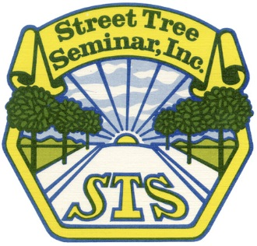
Agenda:
Palmfoolery - Palms are not trees!
Thursday, February 10, 2017
8:30 AM - 4:00 PM
Doors open at 8:00am
Rothenberg Hall
The Huntington Library and Botanic Gardens
San Marino, California

8:00 am Registration Opens

8:30 am Mr. Ken Pfalzgraf, City of Beverly Hills, CA - STS 2017 President
Welcome and Introductions

8:40 am Mr. David Smith, W.D. Young and Sons, Indio, CA
Growing palm trees

9:15 am Mr. Ken Pfalzgraf, City of Beverly Hills, CA
Moving and reestablishing palms in the landscape

10:00 am Break

10:15 am Mr. Donald Hodel, University of California Cooperative Extension, Alhambra, CA
Some new developments and old facts about palm culture

11:30 am Dr. Monica Elliot, University of Florida, Fort Lauderdale, FL
Wilts, blights and rots: Diseases of palms

12:30 pm Lunch* (provided) & Tree ID Challenge- Students vs Professionals

1:15 pm Mr. Javier Quiroz, San Diego Zoo Safari Park, San Diego, CA
Staying safe while working in palms

2:30 pm Mr. Javier Quiroz, San Diego Zoo Safari Park, San Diego, CA
Outdoor palm rescue demonstration

3:30 pm Wrap up/Drawing/CEUs

4:00pm Optional Palm Walk with Don Hodel
Access to the Gardens is included with symposium registration.
Sign up at registration if you are interested.

Visit our table top exhibits:

- ArborJet
- Century Products
- Mauget .
- RPW Services, Inc.
- Tree Pros, Inc.
- Western Chapter ISA

DPR Code:
M-0359-17
2.0- Other
Notes/Observations:
Doodle area:

